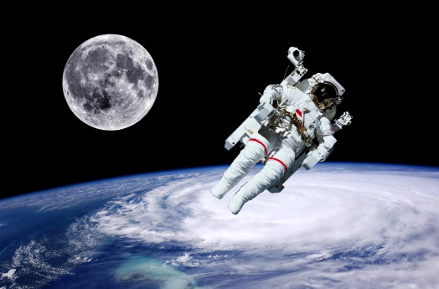Student worksheet

4.2 Sound can travel at different speeds

Pages 72–73 and 194

The speed of sound

1 What is the speed of sound and under what conditions does this occur?

2 Why does the speed of sound vary?

3 What happens to air as it increases in temperature?

4 What does this mean for sound at higher temperatures?

5 What is the relationship between particles and the speed of sound?

6 Does sound travel faster in water or air? Explain why.

7 How fast does sound travel in space? Explain this.

8 On 12 May 2013, Chris Hadfield, on board the International Space Station (ISS), released a music video of his rendition of ‘Space Oddity’ by David Bowie. How was he able to record this in space and have people hear what he was singing?

9 Complete the sentence: The more closely packed the particles in a solid ...

10 In the table below, summarise the speed of sound.

|  |  |  |
| --- | --- | --- |
|  | Causes particles to: | Which means that sound will travel: |
| Increasing temperature |  |  |
| Making something more solid |  |  |

11 Explain how sonar works.

12 Provide 2 applications for sonar.

Extend your understanding

Many daredevils over recent years have dedicated a great deal of time and money to breaking the sound barrier.

13 What is the sound barrier?

14 What happens when you break the sound barrier?

15 Would it be easier to accomplish this in a plane or a car? Explain why.

16 You are travelling very fast in a convertible car and break the sound barrier. You decide to tell this to your best mate sitting beside you. Can your mate hear you? Explain your answer.

17 How fast does a commercial airliner travel? Is this faster or slower than the speed of sound?

18 Can you hear people talk to you when you are on a plane? Explain your answer.